Students Logging into ConnectED

**URL:** [www.cusd80.com](http://www.cusd80.com)

Click on Online Grades in the top right hand corner of the page.

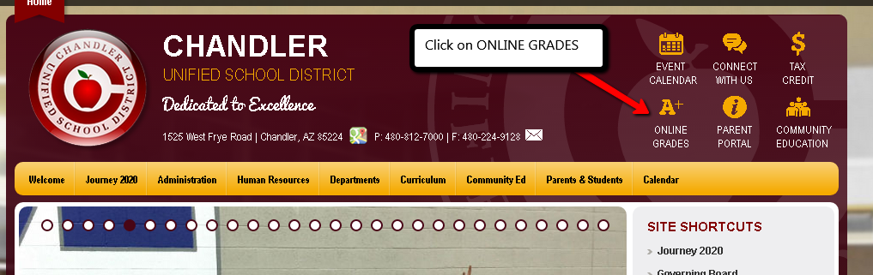

Login to the student portal using your computer username and password. *(****Hint:*** *S + Student#)*

You will click on CUSD Student Links on the left hand side menu closer to the bottom of the screen.

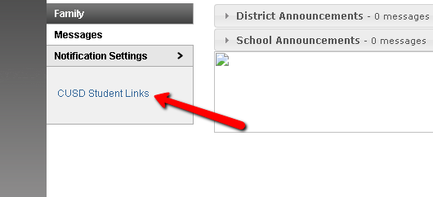

A new tab or window will open up with the available student links. Click on the **ConnectED** application. It will automatically log you in.

